Exercise

01.

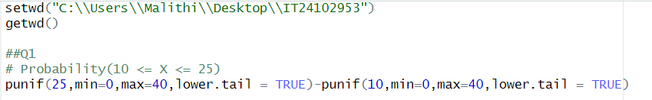

02.





03.

